C# Test

Standard Calculator

Use Microsoft Visual Studio to create a simple calculator application. The Calculator will be developed as a C# Windows Application. The layout will be as follows:

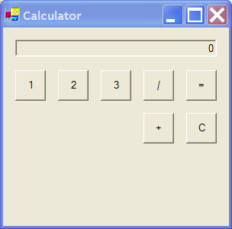

The application must be written with a view to supporting all digits and operators. However, for the purposes of this test, only the digits and operators specified in the screen capture above should be implemented.

The Calculator must satisfy the following criteria:

- Multiple characters can be input e.g. 12 + 32 = 44.
- Multiple operators can be input within a single calculation e.g.
1 + 2 / 3 = 1
1 / 2 + 3 = 3.5
12 + 23 + 3 / 2 = 19
- Operator precedence will be left to right only.
- The ‘C’ button, when pressed, will clear the current calculation and any displayed number.

In all other aspects the Windows Calculator (standard mode) should be consulted for examples of how the application should work.

